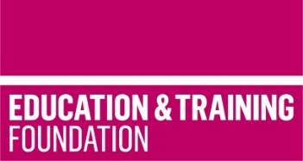 |  | 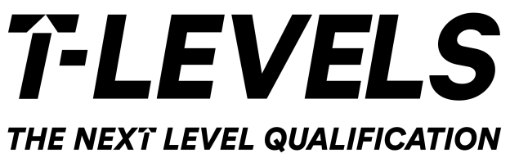

Preparing for T Level Delivery – major lessons from TRIP practitioner research
Nottingham | 11TH MARCH 2020
Skills and Education group, robins wood house, robins wood road, NG8 3nh

A regional dissemination event sharing the insights from Teacher Regional Improvement Projects (TRIP) and Industry Insight activity.
The day will be made up of a series of workshops with guest speakers from post-16 providers (including FE colleges, independent training providers and schools) and a presentation and discussion from an Industry Insight deliverer and an employer, all with opportunities for Q&A, to support providers in preparing for T Level delivery.
There are a range of themed workshops available over the course of the day covering different aspects of teaching T Levels.
Each workshop will give you an insight into a different aspect of T Level delivery and some of the challenges and potential solutions identified by the TRIPs. The workshops will share ideas on;
- Employer engagement
- Inclusion
- Sequencing and assessment
- Staff skills.
Workshops will help to build your knowledge on how each T Level may be taught, your knowledge of the T Level content and support you to enhance your confidence and preparation for T Level delivery.
The event will also give you updates on what’s been happening in the Technical Education and T Level landscape and to hear from FE providers and employers on their progress for September 2020 and future delivery.

Learning outcomes
- Learn about the new practice developed through Teacher Regional Improvement Projects as providers from across the country overcome key challenges to be ready to deliver T Levels
- Learn about the benefits of Industry Insight activity including, employer-led practice and development workshops, with an employer’s perspective on T Levels.

Who is it suitable for?
This conference is for all those involved in T Level delivery across all post-16 providers and schools who will be delivering T Levels, or will support learners to progress to T Levels, in 2020, 2021 and beyond.

AGENDA
09:30 – 09:45 Arrival and refreshments
09:45 – 09:55 Welcome
  - Paul Eeles, Chief Executive, Skills and Education Group
09:55 – 10:15 TRIP Initial Findings
  - Jonathan Poxon, Head of Projects, Skills and Education Group
10:15 – 11:15 Workshop A (Select)
  - Employer Engagement
OR
  - Staff Skills (1)
11:15 – 11:35 Break
11:35 – 12:35 Workshop B (Select)
  - Inclusion
OR

12:35 – 13:20 Lunch and Networking
13:20 – 13:55 Sharing Session
  - The opportunity to meet the TRIP leads/partners and Industry Insight deliverers in a market place ad find out more about their individual TRIPs and activities
14:00 – 14:40 Industry Insights Presentation and Panel Discussion
  - Discussion based on placement case studies and employer and teacher insights into T Level engagement and delivery
14:40 – 15:00 Break
15:00 – 16:00 Workshop C (Select)
  - Sequencing and Assessment (2)
OR
  - Staff Skills (2)

  - Sequencing and Assessment (1)

BOOK YOUR PLACE TODAY
https://booking.etfoundation.co.uk/course/details/709

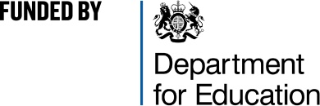

10:15 - 11:15 – WORKSHOP A | Employer Engagement  - SMB Group (formerly Stephenson College): Identifying how best to contact and engage employers  - Chesterfield College: Identifying industry requirements for T Levels  - Richmond upon Thames College: Using employer encounters to deliver a digital curriculum | OR | Staff Skills (1)  - Boston College: Developing bespoke support networks for T Level teachers  - Suffolk New College: Using employer-led masterclasses in construction  - Nottingham College: Understanding contemporary technologies across dentistry, pharmacy and optometry  - Walsall College: Focus on general business elements of T Levels
11:35 - 12:35 – WORKSHOP B | Inclusion  - Derby College Group: Developing inclusive approaches to T Levels  - Harlow College: Identifying barriers to students choosing T Levels  - South Thames Colleges Group: Developing feedback mechanisms to students on T Level courses using digital technology | OR | Sequencing and Assessment (1)  - La Retraite RC Girls School: Sequencing digital schemes of work  - Solihull College: Co-creating a variety of curriculum delivery models for the Digital T Level  - Walsall Studio School: Upskilling teachers to sequence the digital curriculum
15:00 - 16:00 – WORKSHOP C | Sequencing and Assessment (2)  - Ursuline High School: Assessing models of working that will ensure improved and sustained Technical Teaching practice  - Uxbridge College: Developing engagement between employers and T Level specific curriculum staff  - St John Bosco College: Upskilling science staff and development of schemes of work, assessments and resources  - South Essex College: Co-constructing resources and planning for implementation of the first three T Levels | OR | Staff Skills (2)  - New College Stamford: Supporting digital teachers to retain/develop links to industry  - North Hertfordshire College: Improving the readiness of learners to undertake a T Level industry placement by upskilling the staff that support them  - Westminster Kingsway College: Understanding where deficits in skills exist or differences occur between current college practice and industry requirements  - The Mercian Trust: Using drone technology in digital and construction sectors

